



SRI LANKA INSTITUTE OF ADVANCE TECHNOLOGICAL EDUCATION

HIGHER NATIONAL DIPLOMA IN INFORMATION TECHNOLOGY

Individual Project Report

Fortune Agro Supermarket Billing System

Created by Name : A.M.A.I.Munasinghe

Reg Number : KUR/IT/2022/F/0017

2022 1st Year 1st Semester

Supervisor

Ms.P.G.R.N.J.Gamlath

**ACKNOWLEDGEMENT**

I would like to express my deepest gratitude to all those who have contributed to the successful completion of this IT project. Firstly, I extend my heartfelt thanks to my supervisor/advisor Ms.P.G.R.N.J Gamlath, whose guidance, encouragement, and support were invaluable throughout this journey. I am also deeply thankful to the other lecturers, friends, and senior students who generously shared their knowledge, insights, and support, contributing significantly to the success of this endeavor.

This project would not have been possible without the collective effort and support of all those mentioned above.

**ABSTRACT**

The “Fortune Agro Supermarket Billing System” project is aimed at designing and implementing an advanced billing and management system for Fortune Agro Supermarket. This system will revolutionize the way the supermarket handles its operations, from management to customer interactions.

**TABLE OF CONTENT**

Page Number

**01. INTRODUCTION 5**

**01.1. PURPOSE 6**

**01.2. SYSTEM OVERVIEW 6**

**01.3. PROBLEM STATEMENT 7**

**01.4. GOAL AND VISION 7**

**02. REQUIREMENT SPECIFICATION 8**

**02.1. SYSTEM FUNCTIONS 8**

**02.2. SOFTWARE REQUIREMENT 9**

**03. DESIGN 10**

**03.1. FRONT AND END DESIGN 10-11**

**03.2. DATABASE DESIGN 12**

**04. REFERENCES 13**

**01. INTRODUCTION**

The Fortune Agro Supermarket Billing System is a comprehensive software solution designed to streamline the business process within supermarket environment. Developed using Microsoft Access, this system offers a user-friendly interface and robust functionality to efficiently manage sales transactions and customer information.

**User-friendly Interface:**

The system boasts an intuitive interface, making it easy for supermarket staff to navigate and operate.

**Security and Access Control:**

Role-based access control ensures that only authorized personnel can access sensitive information and perform specific actions within the system.

**Customer Information Management:**

The system allows for the management of customer data, including purchase history and contact details.

Overall, the Fortune Agro Supermarket Billing System leverages the power of Microsoft Access to optimize operations and enhance customer satisfaction.

**01.1. PURPOSE**

The “Fortune Agro Billing System” project is aimed at designing and implementing an advanced billing and management system for Fortune Agro Supermarket. This system will revolutionize the way the supermarket handles its operations, from management to customer interactions.

**Efficient Billing Process**:

To automate and simplify the billing process, reducing manual errors and minimizing customer waiting time.

**Recipt Generation**.

To generate clear and detailed receipts for customers, including information about purchased Items, prices and payment methods.

**Cost Control**.

To help the supermarket identify cost-saving opportunities, reduce wastage, and optimize pricing stragies.

**01.2. SYSTEM OVERVIEW**

The MS Access Fortune Agro Supermarket Billing System is a database-driven application designed to streamline billing processes within Fortune Agro Supermarket. It likely includes modules for managing product information, customer details, sales transactions and generating receipts. The system is built using Microsoft Access, which provides a user-friendly interface for accessing and manipulating the data stored in the database. Overall, it aims to automate and simplify the billing operations of the Fortune Agro Supermarket.

**01.3. PROBLEM STATEMENT**

|  |  |
| --- | --- |
| Inefficient Checkout Process: | Customers often experience long wait times at the checkout due to slow transaction processing, resulting in customer dissatisfaction. |
| Pricing Errors: | Pricing errors, such as incorrect product prices or discounts not being applied accurately, can lead to customer disputes and financial losses. |
| System Downtime: | Frequent system downtime or technical issues can disrupt business operations and lead to customer inconvenience. |
| Compatibility Issues: | Compatibility problems between hardware and software components of the billing system can hinder smooth operations. |
| Customer Feedback: | Lack of mechanisms for collecting and responding to customer feedback can result in missed opportunities for improvement and innovation. |

The Fortune Agro Supermarket Billing System Database, the statement of the problem can be summarized as follows:

**01.4. GOAL AND VISION**

The goal of the MS Access Fortune Agro Supermarket Billing System is to optimize the billing processes within the Fortune Agro Supermarket by providing an efficient and user-friendly platform for managing transactions, customer data and enhancing operational efficiency, customer satisfaction and business profitability.

**02. REQUIREMENT SPECIFICATION**

**02.1. SYSTEM FUNCTIONS**

**Functional Requirements**

**1. Product Management:**

Ability to add, edit, and delete products and categorize products by product ID.

**2. Customer Management:**

Ability to add, edit, and delete customers and categorize customers by customer ID.

**3. Billing Process:**

Generate bills for purchases and calculate total amount.

**4. Reporting:**

Generate sales reports for specific time periods.

**5. Security:**

Implement access controls based on user roles and ensure data privacy and protection by using user name and password.

**Non-Functional Requirements**

**1. Compatibility:**

Ensure compatibility with different versions of Microsoft Access.

**02.2. SOFTWARE REQUIREMENT**

**1.Microsoft Access:**

Ensure we have Microsoft Access installed on our system. Access is part of the Microsoft Office suite and is used for database management.

**2.Operating System:**

Microsoft Access is available for Windows operating systems.

**3.Database Design Tools:**

Microsoft Access provides a graphical interface for designing tables, relationships, forms, and reports.

**03. DESIGN**

**03.1. FRONT AND END DESIGN**

**Front Design**

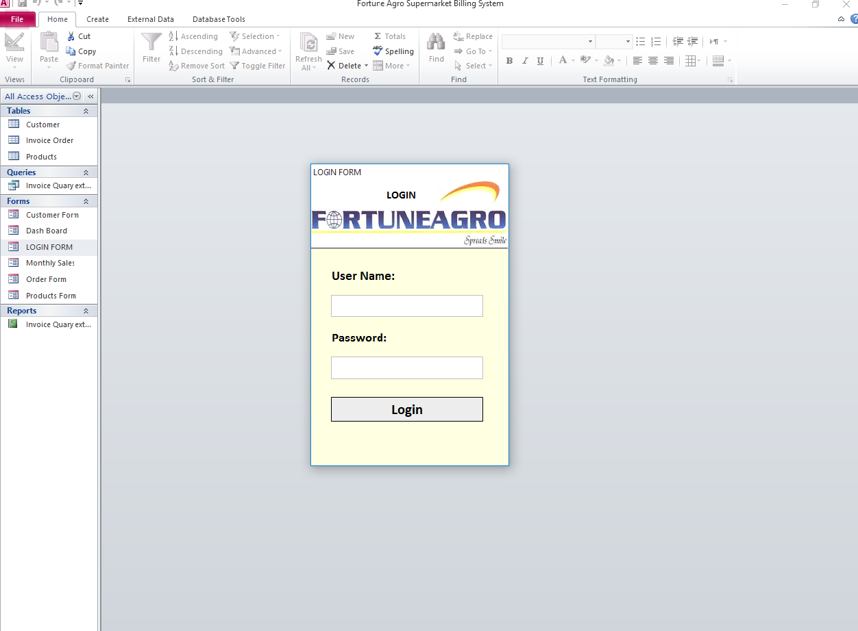

If we enter the wrong login details, display this message.

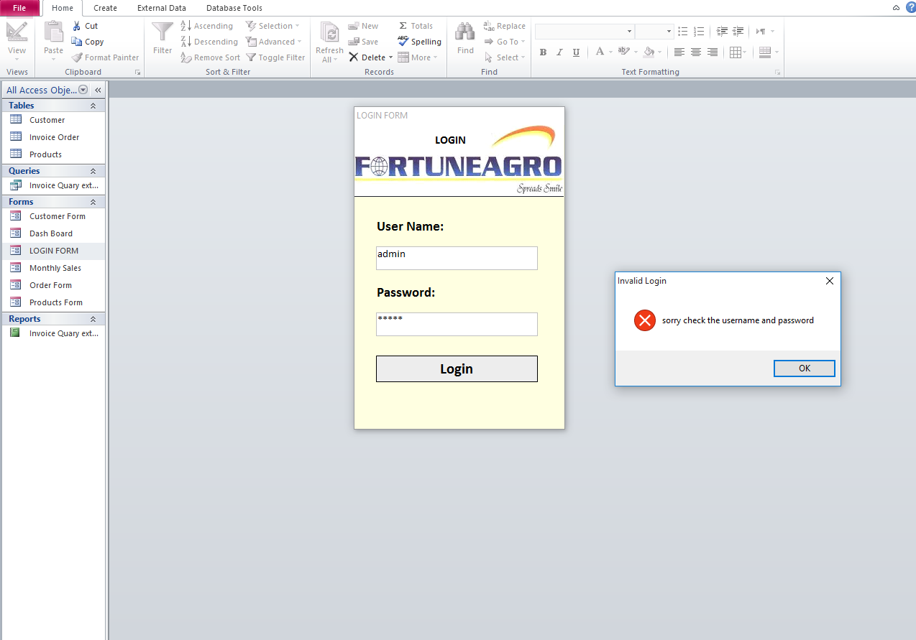

**Dash Board**

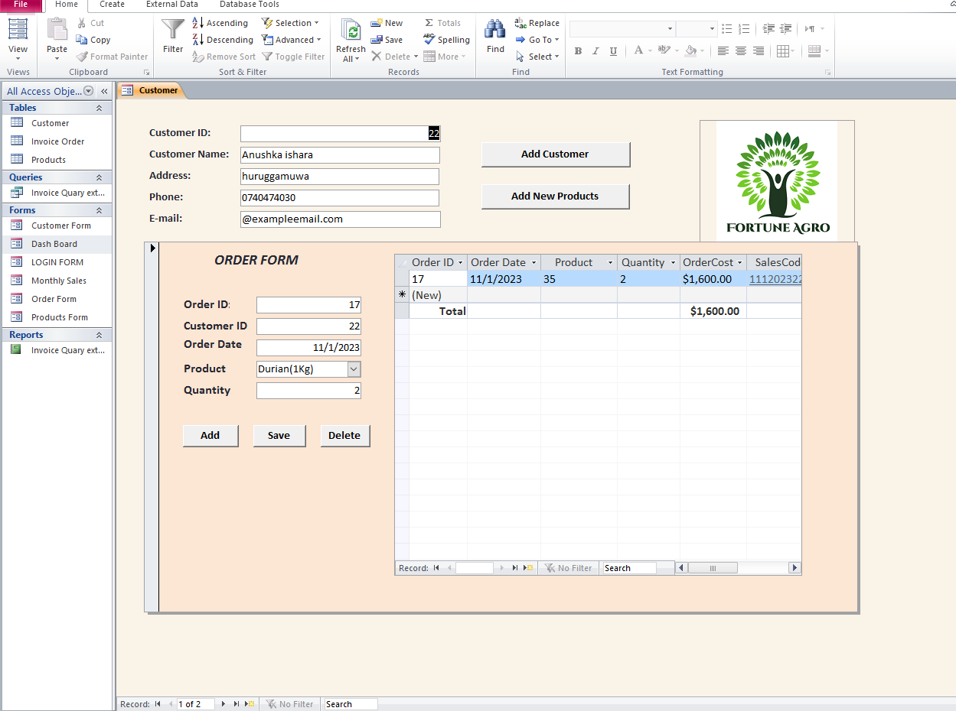

**End Design**

Show customer bill.

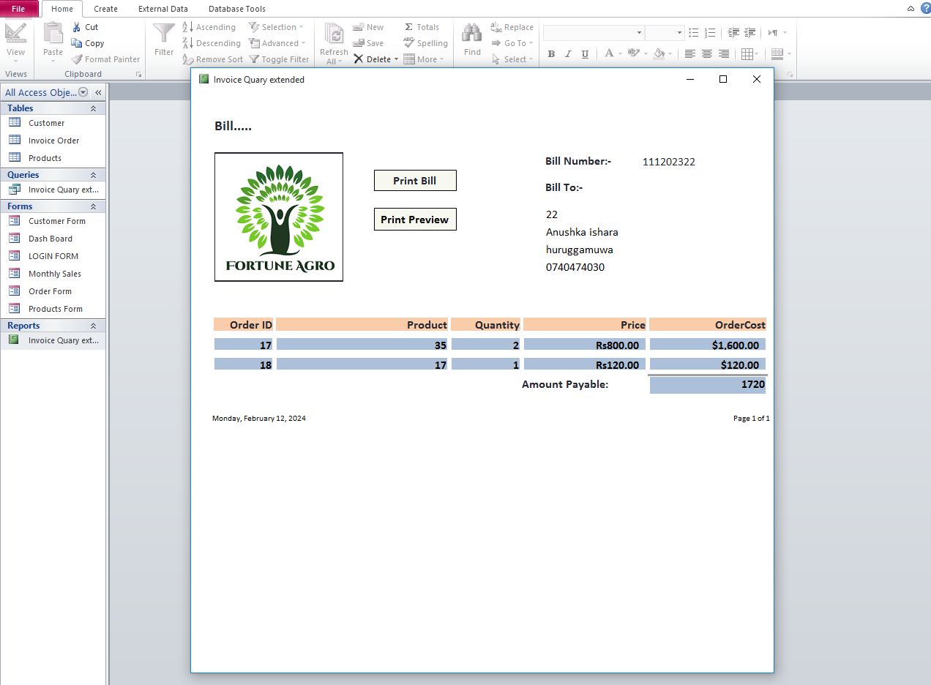

**03.2. DATABASE DESIGN**

**Tables:**

Create tables for products, customers and invoices.

**Relationships:**

Establish relationships between Invoice order and Product.

**Forms:**

**Customer Form**: Allow for managing customer information, such as Name, Address, Phone and Email.

**Product Form**: Allow for managing product information, such as Product no, Batch, Price and Product name.

**Login Form**: Contain User Name and Password.

**Order Form**: Allow for managing order information, such as Order ID, Customer ID, Order Date, Product and Quantity.

**Reports:**

Generate report to analyze customer bill.

**Queries:**

Create queries to retrieve Sales data and perform analysis.

**04. REFERENCES**

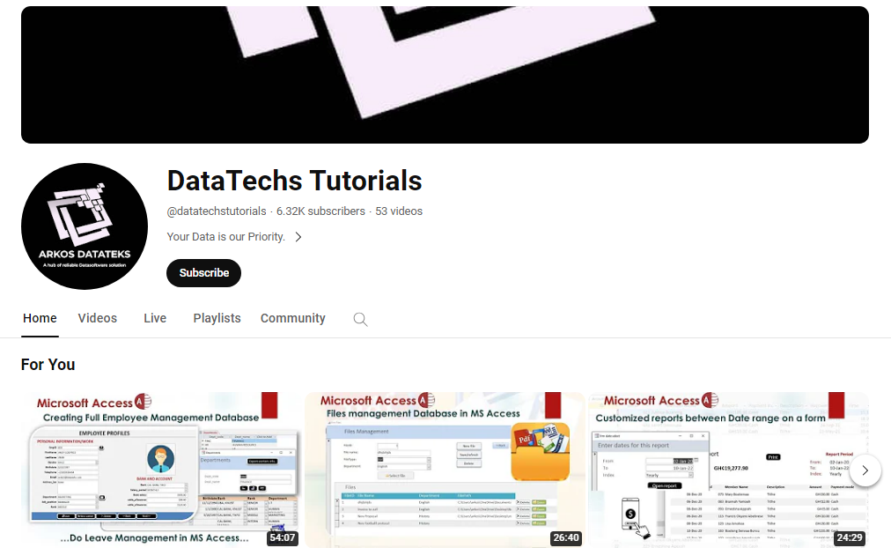

Reference Link: [https://youtu.be/G9i4jZgulfU?si=cynivogaBA6mcmrM](chrome%20-%20Shortcut.lnk)